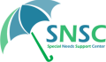
The Special Needs Support Center Volunteer Manual
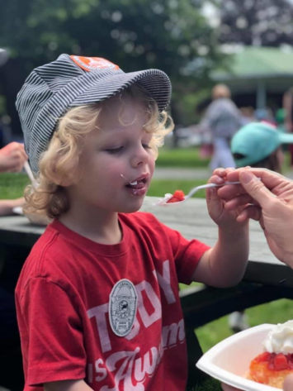

TABLE OF CONTENTS

2 Who We Are
4 Mission, Vision, & Values
4 Sustainability Statement
4 Statement on Inclusion
5 Volunteer Opportunities
5 Parent Educational Support and Advocacy Volunteers
5 Aspire Volunteers
6 Art Lab Volunteers
6 Happenings Volunteers
6 Administrative and “Done in a Day” Project Volunteers
7 Volunteer Etiquette
7 Volunteer Compact
8 Liability Waiver
8 Media Permission & Release
WELCOME
Welcome, and thank you for joining us as a member of our Volunteer Team! We are so happy that you will be working alongside us to make our community a better place.
This team works to provide families with support, information, connections and resources. Volunteers are an integral part of our team, allowing SNSC to support families throughout the Upper Valley with attention and quality services.
It is essential to SNSC’s work and values that community members work together to support families; volunteers exemplify community centered values at their best. We deeply appreciate the time, energy, and care given by our volunteers. We could not do what we do without you.
We hope you enjoy your experience as a volunteer with SNSC. As you learn more about your responsibilities within the program, please feel free to ask questions. We are happy to help you.
It is your commitment that allows SNSC to reach into our Upper Valley Communities and serve our families effectively.
Sincerely,
The Special Needs Support Center Team

WHO WE ARE (Our Staff)
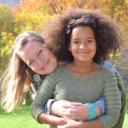
Laura Perez, Executive Director
Laura (she/her) joyfully leads a team of people who are fiercely dedicated to the delivery of transformative programs and amplifying the voices of the community they serve. She is dedicated to people-powered advocacy and organizing. Her passion is to be with her community, listen to what people want and need, and work to make those visions of a reality. She brings over fifteen years of community organization experience to SNSC, having dedicated her career to creating a safer, happier, and healthier place for us all to live, play, and work.
Her baccalaureate education focused on the politics of poverty and community education as a force for social change. She also holds a Master’s in Business Administration with a focus on strategic organizational leadership. In her spare time Laura finds her greatest delight in working side by side with her husband at their small family farm and playing with her children.
Cortney Nichols, Volunteer & Development Coordinator
Cortney grew up in and lives in the Upper Valley with her husband and daughter. She has worked with a variety of nonprofits and is passionate about working to spread awareness and maximize mission impact. Cortney focuses on sharing our mission with the community and building capacity through an impactful volunteer program.
She joined SNSC in the summer of 2022 and fell in love when she met the participants and saw how hard the staff works for our community. “SNSC is making sure that our neighbors and community members aren’t left behind and forgotten. It is inspiring to work with a team that is so passionate about the mission.” Cortney loves to be outside, garden, read, and learn new things!
Carmen Lachle, Adult Services Program Coordinator
In 2018 I was referred to SNSC for Parent Educational Support and Advocacy. I can remember it like yesterday, as it was such a challenging time for my husband Nolan and I. We have three daughters (Lillian, Madalyn, and Sophia) diagnosed with Autism, and I found myself lost with all the IEP and evaluation meetings. Also, I found myself seeking conversations with other parents who understood my challenges and fears related to raising children with disabilities. I was told as a young child that knowledge is power, and as a mother I wanted to be sure I was doing everything possible for all my children. I’m so fortunate that I found SNSC because developing strong relationships is the foundation of everything I do professionally and personally. I have been empowered by knowledge and skills from the wonderful staff, participants, and volunteers within the SNSC community. In my free time I love spending time with my family, friends, cats, and guinea pig. My favorite thing is hearing my children giggle and I really love making tie-dye shirts together as a family.

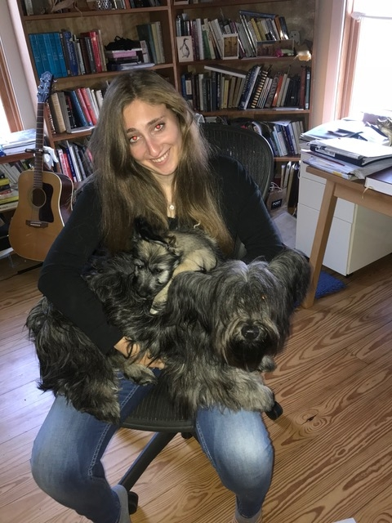
Emma Woloshin, Youth Services Coordinator
Emma (she/her) is passionate about working with people with disabilities and creating equity for all. She was an active member of Unified Sports in high school and discovered her determination for making spaces accessible to everyone, including creating a Unified Prom. She graduated the University of Vermont with a degree in special education and has been working in schools to support students with disabilities. She has a background in Applied Behavioral Analysis and is currently working towards her graduate degree in special education. Outside of work, Emma loves spending time with her family and her dog.

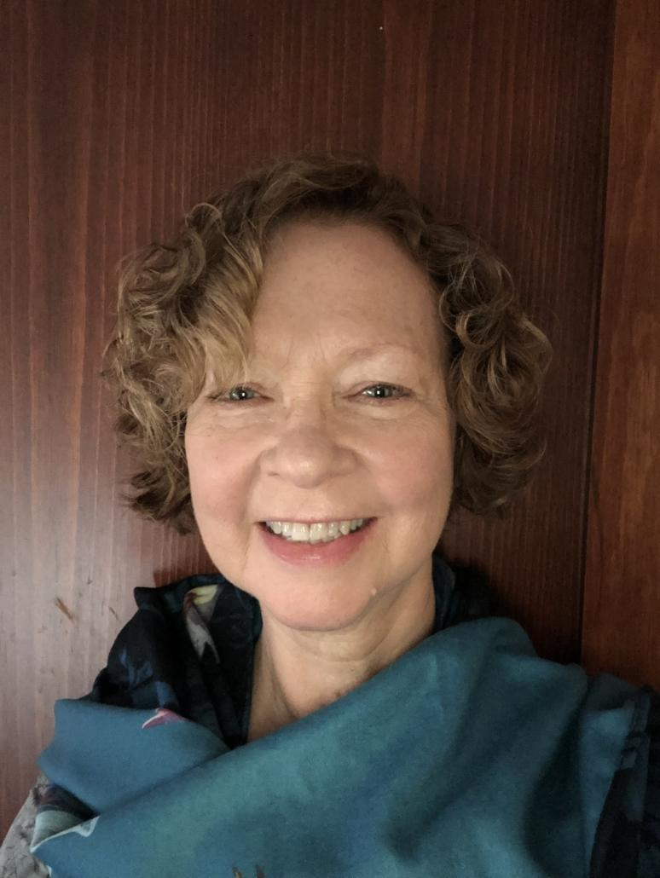
Candace Crosby-Rogers, Advocacy Program Coordinator
Candace (she/her) has been working with people with various differences and needs for over 40 years. As a parent, teacher, and advocate, she is passionate about supporting families and individuals in order for them to gain access to equity in their education and in their lives. Helping to develop programs, supports, and resources to enhance one’s life is a passion of hers, and one that she is able to use in her interactions as an advocacy coordinator.
She has worked in schools in Massachusetts and now lives in Vermont, where she was a special education teacher and an early childhood special education coordinator. Candace has a B.A in Psychology from the University of Massachusetts, and a Masters in Special Education from Framingham University.
She enjoys making pottery and traveling to visit her children and grandchildren.

MISSION, VISION, & VALUES

Mission Statement
We are a group of individuals and families throughout the Upper Valley and beyond who proudly work together to create a community where people with special needs, across the spectrum and throughout the lifespan, can live their best lives.

Vision
All people with special needs, and their families, have opportunities and support to pursue their goals and aspirations.

Core Values
- We believe that program participants, families, volunteers, donors, staff, and the board of directors are the most valuable assets of the organization.
- We believe relationships are resources.
- We honor the people we serve as experts, partners, and decision makers.
- We support resiliency in families.
- We respect and celebrate each individual.
- We foster knowledge sharing and collaboration.
- We create a culture of dignity, respect, and compassion.
- We embrace diversity as an essential component of community well-being.
- We maintain an environment of community, financial, and environmental sustainability.
Sustainabity Statement
With courage, integrity, and love, we embrace our responsibility to program participants, families, volunteers, donors, staff, board of directors, and the environment to operate our organization sustainably by:
- Creating a healthy, safe, collaborative and innovative work environment;
- Being deliberate with our funds and increasing productivity through thoughtful resource
allocation; and
- Promoting environmentally responsible decision making and reducing waste.
STATEMENT ON INCLUSION
We genuinely value a diverse volunteer workforce and inclusive culture and to reflect that in all of our actions. We strive to model inclusivity in all our actions. We promise to promote a safe, compassionate space free of intimidation, harassment, and discrimination. We encourage and welcome participation from all community members without restriction. We do not discriminate
for any reason, including but not limited to race, color, religion, gender, sexual orientation, gender identity and expression, age, national origin, marital or economic status, citizenship, disability, or veteran or military status. And we expect similar respect from and toward everyone who volunteers at or visits our space. SNSC is and will remain a safe place, free of bias and hatred.
VOLUNTEER OPPORTUNITIES
There are many ways to get involved in the Special Needs Support Center. Remember, we cannot do this without you. Because of you, families across the greater Upper Valley will enjoy programming, services, and support. Thank you for dedicating your time and energy in this way.
Parent Educational Support and Advocacy Volunteers
We provide support in a variety of ways to parents about all aspects of the special education and Section 504 process to:

- Promote understanding of the relevant state and federal rules, regulations and typical processes for Special Education and Section 504.
- Provide assistance in planning for meetings and contacts with school personnel. • Provide understanding the array of testing and evaluations that are done to determine possible eligibility for special education and Section 504 plans.
- Provide an extra pair of eyes and ears at IEP or 504 meetings, support parents in clarifying their ideas and concerns and assisting them in voicing these at school meetings.
- Participate, at parent request, as a full member of the IEP or Section 504 team in support of providing student with a free and appropriate education (FAPE).

Aspire Volunteers
Aspire is a recreation program for children and teens with disabilities which is offered throughout the year. In this program, participants enjoy activities that encourage the development of communication and social skills through modeling and practice. We identify individualized skills and goals and work on them through group play and community exploration.

Make a positive difference in lives of children and teens with disabilities and their whole families by:
- Building positive relationships between participants, SNSC staff, and Aspire volunteers through recreation and play.
- Creating an open forum for parents and caregivers to support each other by sharing experiences, knowledge and concerns.
- Supporting existing therapeutic interventions by providing real-life opportunities for application.
- Promoting inclusion and quality of life by embracing each child’s extraordinary strengths.
This volunteer opportunity typically takes place at various locations in White River Jct and the Upper Valley. Our afterschool program is Mon-Friday 2:30-5:30, we also offer camp during vacation weeks, and the Aspire Summer Camp (9-3, Mon-Fri, through the summer).

Art Lab
Art Lab is a weekly open studio art program for adults and teens with special needs implemented in collaboration with SNSC and AVA Gallery and Art Center. The participating artists get a chance to explore different media with an emphasis on creative self-expression while socializing.

As a volunteer, you will support artists with their self-expression of art by:
- Setting up supplies
- Cleaning up supplies
- Encouraging and supporting participants with art projects
- Allowing open studio concepts
- Socializing and building relationships with participants
This volunteer opportunity typically takes place at AVA on Wednesdays from 10:00-11:30 am and 3:30-4:30 pm weekly.
Happenings
Happenings is a regularly scheduled social activities program for adults with special needs. Volunteers support a rich variety of activities including but not limited to day trips, field trips with Zack’s Place, apple picking, christmas caroling, and dances. Volunteers help everyone stay safe and have fun, support participants in the activities, and socialize and build relationships with participants.

We are looking for enthusiastic team players who are excited to work with adults with disabilities, and have a desire to learn new communication skills to engage with all people. We ask that all volunteers keep a lookout for any participant who may be having a difficult time or is being unsafe. Roles may include:

- Sign-in greeting
- Decorating
- Running music
- Raking/printing photos
- Washing dishes
- Preparing food
- Supporting a safe and fun environment
- And more!

We have a variety of time commitments, which could range from once a month for a few hours, to a couple of hours a week. This program takes place at a variety of community locations and the SNSC office.
Administrative Projects and Done-in-a-Day Projects
Interested in volunteering but don’t have the capacity for a long term commitment? We would love your help with mailings, office painting, window cleaning, organizing, and other chores.
Do you have time to help gather petition signatures for SNSC? Each fall SNSC is required to submit petitions to towns in order to get on town ballots and ask for annual town funding.

VOLUNTEER ETIQUETTE

- Be patient and kind.
- Be consistent and excellent.
- Have fun!
- Disrespectful, aggressive, abusive, and/or destructive language or behavior is not welcome at SNSC.
- Show up on time and ready to contribute.
- When in doubt, ask, ask, ask.
VOLUNTEER COMPACT
As a member of the SNSC Volunteer Team, I will:
- Work in good faith with SNSC Staff and other Volunteers as partners toward achievement of our goals.
- Participate actively in the role and arrive well prepared.
- Be accountable for my actions, reliable in my responsibilities, and respectful of others.
- Give notice in a timely manner if unable to continue with the role.
To support my role, the SNSC Team will:
- Provide volunteers the rich opportunity to be part of a team where strong working relationships with community members is valued and the community of Volunteers is nurtured.
- Provide new Volunteers with an onboarding process.
- Offer ongoing education, training, and experiences.
Thank You and Welcome to the SNSC Team!

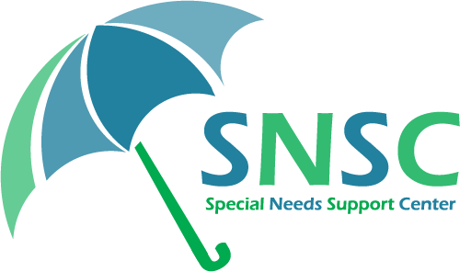Volunteer Form
LIABILITY WAIVER
By signing my name on this form, I hereby release and discharge the Special Needs Support Center from responsibility for any bodily harm or damage or loss of whatever kind arising from or in any manner or form connected with my volunteer role at the Special Needs Support Center.

Your signature __________________________________________ Date: ____________
Print your name _________________________________________
Parent/Guardian Signature (if you’re under 18 or in guardianship):
___________________________________ Date: ______
Parent/Guardian Name: _________________________________________
Phone number __________________________________________
Email address __________________________________________
I give permission for SNSC to communicate with me through email: 𛲠
Emergency contact (please print): _________________________________________
Phone number: _________________________________________

MEDIA PERMISSION & RELEASE
For consideration which I acknowledge, I irrevocably grant to the Special Needs Support Center the right to use my image, voice, and name in all forms and media, including composite or modified representations for all purposes. I waive the right to inspect or approve versions of my image used for publication or the written copy that may be used in connection with the images. The Special Needs Support Center is permitted, although not obligated, to include my name as a credit in connection with the image or recording. I have read and understood this agreement. This Agreement expresses the complete understanding of the parties.
Yes, I give permission for SNSC to use a photo/video of me/my child: 𛲠
No, I do not give permission for SNSC to use a photo/video of me/my child: 𛲠

